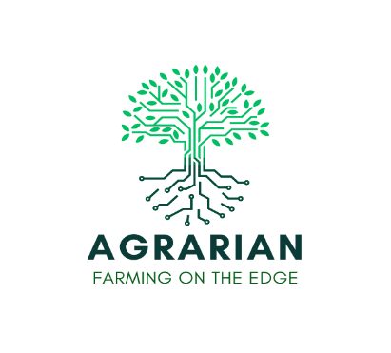

SME DECLARATION
I, the undersigned, [name and surname], in my capacity as [position], representing the company [company name], declare under my own responsibility that the company meets the definition of a small and medium enterprise (SME) as per the definition provided by the European Commission https://ec.europa.eu/docsroom/documents/42921

Company Legal Name
VAT Number
Legal Address
Country
Date of Foundation (DD/MM/YYYY)
Country
Email Address

Type of enterprise
Tick to indicate which case(s) applies to your enterprise:
PLEASE CAREFULLY READ THE DEFINITION OF EACH CATEGORY BEFORE SELECTING THE CASE THAT APPLIES TO YOUR COMPANY.
​​☐Autonomous enterprise
- Does not have holding of 25% or more in any other enterprise AND
- Is not 25% or more owned by any enterprise or public body or jointly by several linked enterprises or public bodies, apart from some exceptions like public investment corporations, venture capital companies, individuals or groups of individuals with a regular VC activity provided the investment is smaller than 1,25M€, universities or non-profit research centres or institutional investors AND
- Does not draw up consolidated accounts and is not included in the accounts of an enterprise which draws up consolidated accounts and is thus not a linked enterprise.

​​☐Partner enterprise
- My enterprise holds a majority (>50%) of the shareholders’ or members’ voting rights in another OR
- Another enterprise holds a majority (>50%) of the shareholders’ or members’ voting rights in my enterprise OR
- My enterprise has the right to appoint or remove a majority (>50%) of the administrative, management or supervisory body of another enterprise OR

☐Linked enterprise
- My enterprise holds a majority (>50%) of the shareholders’ or members’ voting rights in another OR
- Another enterprise holds a majority (>50%) of the shareholders’ or members’ voting rights in my enterprise OR
- My enterprise has the right to appoint or remove a majority (>50%) of the administrative, management or supervisory body of another enterprise OR
- Another entity has the right to appoint or remove a majority (>50%) of the administrative, management or supervisory body of my enterprise OR
- My enterprise has the right to exercise a dominant influence over another entity (pursuant to a contract or a provision in the memorandum or articles of association) OR
- A contract enables another entity to exercise a dominant influence over my enterprise OR
- My enterprise, which is a shareholder in or member of another enterprise, controls alone, pursuant to an agreement with other shareholders in or members of that enterprise, a majority (>50%) of shareholders' or members' voting rights in that enterprise OR
- Another enterprise, which is a shareholder in or member of my enterprise, controls alone, pursuant to an agreement with other shareholders in or members of my enterprise, a majority (>50%) of shareholders' or members' voting rights in my enterprise.

Accounts and Size
Please add the information of your last 2 financial accounting years. If your company has less than two closed financial years provide: last closed financial year + current financial year estimations OR current financial year estimations + next year estimations.

Year | Headcount (AWU) | Balance Sheet (in €) | Turnover (in €)
<2023>
<2024>
Change the year number as needed for your case.
AWU means Annual Working Unit: 1 person full time the whole year is 1. 1 person full time during 6 months is 0.5.

Shareholding Structure
Only provide the information of shareholders owning over a 25% of your shares. Leave empty if it does not apply.

Shareholder  (add the legal name company or natural person) | VAT Number or ID number | % shares

Investments by the Company
Only provide the information of the investments by the company in other companies if those are higher than a 25% of their ownership. Leave empty if not applicable.

Company Invested  (add the legal name company or natural person) | VAT Number of the invested companies | % shares owned

I declare, to my wider extent the information provided is true. I understand I could be requested additional information and binding documents on the accounts and the ownership by AGRARIAN consortium any doubt should be arisen.

Signature: ______________________________________
(Name and position of the signatory, being authorized to represent the enterprise):

Date: _____________________

