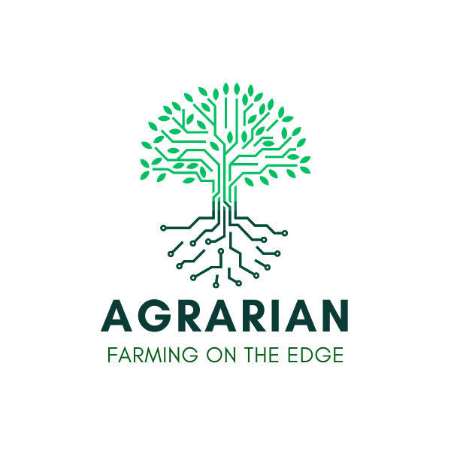

Contents
1. Legal and Contact Information 2
2. Project Information 5
3. Technical Excellence 5
4. Impact 6
5. Implementation 6
6. Annex (Declaration of Honour and Privacy Policy) 8

Project website | https://agrarian-project.eu/
Applications Opening date: | August 1st 2025
Applications Closing date: | September 30th 2025, 17:00 CET (Brussels time)
Open Call 2 platform: | https://agrarian.appliobox.gr/

All Open Call 2 documents and templates are available for download at https://agrarian-project.eu/open-calls/ and through the application platform.

IMPORTANT: The allowed font type is “Arial” and the minimum font size is 11 points, the paragraph spacing 6pt and the line spacing single. The page size is A4, and all margins (top, bottom, left and right) must be at least 15 mm (not including any footers or headers). Proposals that do not comply with these requirements will be excluded from evaluation as non-eligible.
The total length of sections 2-5, must not be more than 12 pages.
You may remove the green explanatory text in the proposal template (located below the paragraph sub-titles).
Evaluators are instructed to dismiss the pages after the specified page limits from the evaluation.

1. Legal and Contact Information

1.1 Application Coordinator Information
First Name
Last Name
Organization
Phone Number (incl. Country Code)
Gender (Woman/Man/Non-Binary)

1.2 Consortium Information
Coordinator Information (Partner 1)
Role in the project
Organization Legal Name
Organization Type (Start-up/SME/University/Research Center/NGO/Foundation)
Legal representative
Contact person (if different than legal representative)
Legal Address:
City/Town:
Province/Region/County:
Phone Number (incl Country Code):
Organization's Website:
VAT Number or Tax Identification Number:
PIC Number:

Partner 2 Information
Role in the project
Organization Legal Name
Organization Type (Start-up/SME/University/Research Center/NGO/Foundation)
Legal representative
Contact person (if different than legal representative)
Legal Address:
City/Town:
Province/Region/County:
Phone Number (incl Country Code):
Organization's Website:
VAT Number or Tax Identification Number:
PIC Number:

Partner 3 Information
Role in the project
Organization Legal Name
Organization Type (Start-up/SME/University/Research Center/NGO/Foundation)
Legal representative
Contact person (if different than legal representative)
Legal Address:
City/Town:
Province/Region/County:
Phone Number (incl Country Code):
Organization's Website:
VAT Number or Tax Identification Number:
PIC Number:

2. Project Information

2.1 Project Name:

2.2 Project Acronym:

2.4 Testbed Addressed:
(Select only one and delete the other options)
- Testbed 1 - Geosynchronous Satellite Communications with EDGE Capabilities.
- Testbed 2 - Non-Geosynchronous Orbit (NGSO) Satellite Communications with EDGE capabilities.
- Testbed 3 - LEO-Based NB-IoT Testbed for Onboard Edge AI Data Processing.

2.5 Use Case Addressed:
(Select only one and delete the other options)
- Use Case 1 - Livestock
- Use Case 2 - Field Crops
- Use Case 3 - Other related farming activity: (please specify)

2.5 Country of the Use Case: (provide information about the location of the use case)

3. Technical Excellence
3.1 Project Description:
(Describe clearly the project you would like to develop, providing the objectives, the system architecture, a diagram and the methodology that you will follow)

3.2 Use Case Contribution of your Project to the Vision and Objectives of AGRARIAN.
(What specific contributions will your project make to the achievement of AGRARIAN's vision and objectives and how does it differentiate from other projects in the same field?)

3.3 Outline how the proposed application/solution addresses the specific challenges in the selected use case exploiting the capabilities of the selected AGRARIAN testbed.

3.4 Ambition over current state of technologies related to your application/solution. (What improvements will you develop over the current state of technology in the field of agriculture and specifically of the selected use case exploiting the capabilities of the selected testbed/dataset?)
3.5 Describe the role of each partner in the consortium.

3.6 How does your project address and assure the gender dimension and what measures are/will be taken to address this?

3.7 Describe the project contribution to open science.

4. Impact
4.1 Describe the scientific impact

4.2 Describe the societal, environmental and other sustainability impact

4.3 Describe the financial impact

4.4 Describe the Communication Plan (This activity refers to the communication of the organizations participation in the AGRARIAN project to relevant communities and the general public. It involves creating a strategy to ensure that the projects outcomes and impacts reach the intended audience through various channels, such as social media, website, press releases, newsletters and events)
4.5 Describe the Dissemination Plan (Dissemination of project results involves sharing the outcomes and findings of the project with the relevant stakeholders and the general public. This process helps to maximize the impact of the project and increase awareness of its outcomes and may involve various strategies such as publications, conferences, social media and other forms of communication. The aim is to ensure that the project results reach as wide an audience as possible and can be used to inform future research and decision-making)
4.6 Describe the Exploitation Plan (Explain the strategy for the exploitation of the results of your projects, such as product commercialization, collaboration with organizations for further development, licensing etc.)

5. Implementation
5.1 Activity Plan: (Please ensure that your activity plan for the project is clear and detailed, providing a comprehensive explanation of what your organization intends to do to achieve the project goals. Additionally, clarify how these activities will directly support the project objectives)
5.2 Please include a Gantt Chart (showing all the planned activities for the project execution)
5.3 Risk Assessment: (Present a thorough assessment of all the risks that your project could potentially face as well as mitigation measures for addressing or avoiding those risks)

5.4 KPIs List and Description: (Provide a list of key performance indicators (KPIs) that will serve as your benchmark. This list should include a mix of operational KPIs and exploitation, communication and dissemination KPIs. Ensure that exploitation, communication and dissemination KPIs make up at least 25% of the total, while the operational KPIs account for the remaining 75%)

5.5 Provide a short profile of the partners’ organizations (describe the area of expertise and how they will contribute to achieve the project goals and objectives)

5.6 Provide short CVs of team members for each partner (describe how they will contribute to achieve the project goals and objectives and what experience and skills do the team members have that are relevant to the project)

----- PAGE LIMIT UNTIL HERE: 12 PAGES (excluding first page and section 1) -----

6. Annex (Declaration of Honour and Privacy Policy)
Declaration of Honour
By submitting this form, the proposal coordinator on behalf of the consortium hereby, certify that (subject to the additional declarations below):
- The information provided for this project is correct and complete.
- The information concerning the legal status in the Application for each organization is correct and complete and concurs with the stipulations outlined in the Guidelines for Applicants.
- Each organization commits to comply with the eligibility criteria set out in the call for proposals for the entire duration of the action.
- Each organization:
- is committed to participate in the action;
- has stable and sufficient sources of funding to maintain the activity throughout the action and to provide any counterpart funding necessary;
- has or will have the necessary resources needed to implement the action;
- acknowledges to be fully responsible for other linked third parties;
- is committed to comply with the highest standards of ethical principles and research integrity and confirm that the work is free of plagiarism;
- Each organization is NOT subject to an administrative sanction (i.e., exclusion or financial penalty decision);
- Each organization is NOT in one of the following exclusion situations:
- bankrupt, being wound up, having the affairs administered by the courts, entered into an arrangement with creditors, suspended business activities or subject to any other similar proceedings or procedures;
- in breach of social security or tax obligations.
- Each organization (or persons having powers of representation, decision-making or control, beneficial owners or persons who are essential for the award/implementation of the grant) are NOT in one of the following exclusion situations:
- guilty of grave professional misconduct;
- committed fraud, corruption, links to a criminal organization, money laundering, terrorism-related crimes (including terrorism financing), child labor or human trafficking;
- shown significant deficiencies in complying with main obligations under an EU procurement contract, grant agreement or grant decision;
- guilty of irregularities within the meaning of Article 1(2) of Regulation No 2988/95;
- created under a different jurisdiction with the intent to circumvent fiscal, social, or other legal obligations in the country of origin (including creation of another entity with this purpose).
- Each organization is NOT subject to a conflict of interest in connection with this grant and will notify without delay any situation which could give rise to a conflict of interests.
- Each organization has NOT and will NOT, neither directly nor indirectly, grant, seek, obtain, nor accept any advantage in connection with this grant that would constitute an illegal practice or involve corruption.
- Each organization has not received any other EU grant for this project and will give notice of any future EU grants related to this project AND of any EU operating grant(s) given to my organization.
- Each organization is aware that false declarations may lead to rejection, suspension, termination or reduction of the grant and to administrative sanctions (i.e., financial penalties and/or exclusion from all future EU procurement contracts, grants, prizes and expert contracts).

Privacy Policy
By submitting this form, the proposal coordinator on behalf of the consortium agrees and confirms the following:
- The consortium has read, understood and will comply with the open call details and requirements stated in the Guidelines for applicants.
- All information provided in the AGRARIAN application submitted by the consortium is correct and complete.
- Each organization is not in any situation which would exclude the consortium from receiving financial support for third parties.
- Each organization is not under liquidation or in financial difficulty.
- Each organization is not subject to a conflict of interest in connection with the cascade funding.
- We will inform the AGRARIAN consortium, without delay, of any situation considered a conflict of interest or which could raise a conflict of interest.
- We will process any personal data in compliance with the applicable EU and national law on data protection.

